|  |
| --- |
| **18EES101J-BASIC ELECTRICAL AND ELECTRONICS ENGINEERING (LAB)** |
| **RECORD**  **SEMESTER I**    **ACADEMIC YEAR: 2020-21**  **NAME : *Tambe Utkarsh Yashwant.*** REG. NO. : *RA2011027010166* C:\Users\System 1\Desktop\11.png  **DEPARTMENT OF ELECTRICAL & ELECTRONICS ENGINEERING**  **FACULTY OF ENGINEERING & TECHNOLOGY**  **SRM INSTITUTE OF SCIENCE AND TECHNOLOGY**  (Formerly SRM University, Under section 3 of UGC Act, 1956)  **S.R.M. NAGAR, KATTANKULATHUR – 603 203**  **KANCHEEPURAM DISTRICT** |



**SRM Institute of Science and Technology**

(Deemed to be University)

**S.R.M. NAGAR, KATTANKULATHUR -603 203**

**KANCHEEPURAM DISTRICT**

**BONAFIDE CERTIFICATE**

**Register No. : *RA2011027010166***

Certified to be the bonafide record of work done by *Tambe Utkarsh Yashwant* of *Computer Science & Engineering department*, B.Techdegree course in the Practical of 18EES101J Basic Electrical and Electronics Engineering in **SRM IST, Kattankulathur** during the academic year 2018-2019. **Lab in-charge**

**Date: Year Co-ordinator**

Submitted for end semester examination held in______________________ Lab, SRMIST**,** Kattankulathur**.**

**Date: Examiner-1 Examiner-2**

**LIST OF EXPERIMENTS**

1. Verification of Kirchhoff’s laws

2. Verification of All Theorems (Thevenin’s theorem, Norton’s theorem, Maximum power transfer theorem)

3. Transient analysis of RL an RC series circuits

4. Load test on single phase transformer

5. Demo of DC/AC machines & Parts

6. Types of wiring (fluorescent lamp wiring, staircase wiring)

7. Characteristics of semiconductor devices (PN junction, Zener diode, BJT)

8. Wave shaping circuits (Half and full wave rectifier, clipper)

9. Displacement measurement using LVDT and pressure measurement using Strain gauge

10. Verification and interpretation of Logic Gates.

11. Reduction of Boolean expression using K-map

12. Study of modulation and demodulation techniques.

**INDEX**

|  |  |  |  |
| --- | --- | --- | --- |
| **Sl. No.** | **Name of the Experiment** | **Marks (50)** | **Signature**  **of the Staff** |
| 1 | Verification of Kirchhoff’s laws |  |  |
| 2 | Verification of All Theorems  (Thevenin’s theorem, Norton’s theorem, Maximum power transfer theorem) |  |  |
| 3 | Transient analysis of RL an RC series circuits |  |  |
| 4 | Load test on single phase transformer |  |  |
| 5 | Demo of DC/AC machines & Parts |  |  |
| 6 | Types of wiring ( fluorescent lamp wiring, staircase wiring) |  |  |
| 7 | Characteristics of semiconductor devices  (PN junction, Zener diode, BJT) |  |  |
| 8 | Wave shaping circuits  (Half and full wave rectifier, clipper) |  |  |
| 9 | Displacement measurement using LVDT and pressure measurement using Strain gauge |  |  |
| 10 | Verification and interpretation of Logic Gates. |  |  |
| 11 | Reduction of Boolean expression using K-map |  |  |
| 12 | Study of modulation and demodulation techniques. |  |  |

DEPT. OF ELECTRICAL & ELECTRONICS ENGINEERING

SRM INSTITUTE OF SCIENCE AND TECHNOLOGY, Kattankulathur – 603 203

|  |
| --- |
| Title of Experiment : **2. VERIFICATION OF ALL THEOREMS-**  **( THEVEN,** NORTON,  MAXIMUM POWER TRANSFER ) |
| Name of the candidate : *Tambe Utkarsh Yashwant*.  Register Number : *RA2011027010166*  Date of Experiment : *08th October, 2020* |

|  |  |  |  |
| --- | --- | --- | --- |
| Sl.  No. | Marks Split up | Maximum marks  (50) | Marks obtained |
| 1 | Pre Lab questions | 5 |  |
| 2 | Preparation of observation | 15 |  |
| 3 | Execution of experiment | 15 |  |
| 4 | Calculation / Evaluation of Result | 10 |  |
| 5 | Post Lab questions | 5 |  |
| **Total** | | **50** |  |

Staff Signature

**PRE LAB QUESTIONS**

**1. Define Lumped and distributed elements.**

**Ans :-***Lumped elements:*

*In electrical circuits if the physical size of the element is negligibly small when compared with wave length of electromagnetic wave propagation then the element is modelled as lumped elements. The lumped element can be represented with its parameters like resistance or inductance with its total value at a place.*

*Examples: Resistors, inductors, capacitors.*

*Distributed elements:*

*If the physical size of the element is comparable with wavelength of electromagnetic wave propagation then such an element is modelled as distributed element. In these elements resistance, inductance or capacitances are distributed and cannot be separated and modelled at a single point. These are distributed throughout the circuit.  
Example: Long transmission lines-in which the resistance, capacitance and inductances are distributed throughout the line. Elements in high frequency electronic circuits.*

**2. State Thevenin’s theorem?**

**Ans :- *Thevenin’s Theorem****states that “*Any linear circuit containing several voltages and resistances can be replaced by just one single voltage in series with a single resistance connected across the load*“.*

**3. State Norton’s theorem?**

**Ans :- *Norton’s Theorem****states that “*Any linear circuit containing several energy sources and resistances can be replaced by a single Constant Current generator in parallel with a Single Resistor*“.*

**4. List the applications of Thevenin’s and Norton’s theorems?**

**Ans :-** ***Norton’s equivalent circuit*** *is used to represent any network of linear sources and impedances at a given frequency.*

***Thevenin’s equivalent circuit*** *are widely used for circuit analysis simplification and to study circuit's initial-condition and steady-state response.*

**5. What are the different types of dependent or controlled sources?**

**Ans :-** *1) Voltage Controlled Voltage Source (VCVS)*

*2) Voltage Controlled Current Source (VCCS)*

*3) Current Controlled Voltage Source (CCVS)*

*4) Current Controlled Current Source (CCCS).*

|  |  |
| --- | --- |
| **Experiment No. 2 a)**  **Date : 08/10/2020** | **THEVENIN’S THEOREM** |

**Aim:**

To verify Thevenin’s theorem and to find the full load current for the given circuit.

**Apparatus Required:**

|  |  |  |  |
| --- | --- | --- | --- |
| Sl.No. | Apparatus | Range | Quantity |
| 1 | RPS (regulated power supply) | (0-30V) | 2 |
| 2 | Ammeter | (0-10mA) | 1 |
| 3 | Resistors | 1KΩ, 330Ω | 3,1 |
| 4 | Bread Board | -- | Required |
| 5 | DRB | -- | 1 |

**Statement:**

Any linear bilateral, active two terminal network can be replaced by a equivalent voltage source (VTH). Thevenin’s voltage or VOC in series with looking pack resistance RTH.

**Precautions:**

1. Voltage control knob of RPS should be kept at minimum position.
2. Current control knob of RPS should be kept at maximum position

**Procedure:**

1. Connections are given as per the circuit diagram.
2. Set a particular value of voltage using RPS and note down the corresponding ammeter readings.

**To find VTH**

1. Remove the load resistance and measure the open circuit voltage using multimeter (VTH).

**To find RTH**

1. To find the Thevenin’s resistance, remove the RPS and short circuit it and find the RTH using multimeter.
2. Give the connections for equivalent circuit and set VTH and RTH and note the corresponding ammeter reading.
3. Verify Thevenin’s theorem.

**Theoretical and Practical Values**

|  |  |  |  |  |  |
| --- | --- | --- | --- | --- | --- |
|  | E(V) | VTH(V) | RTH(Ω) | IL (mA) | |
| Circuit - I | Equivalent Circuit |
| Theoretical | 20 | 9.9 | 495 | 6.62 | - |
| Practical | 20 | 10 | 495 | 6.69 | - |

**Circuit - 1 : To find load current**

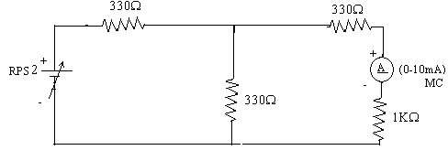

**To find VTH**

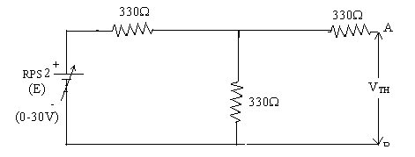

**To find RTH**

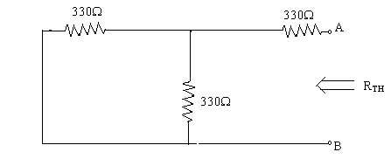

**Thevenin’s Equivalent circuit:**

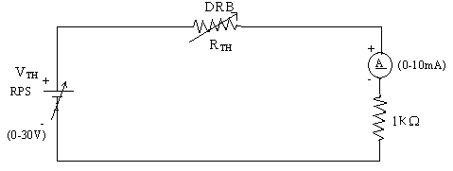

**Model Calculations:**

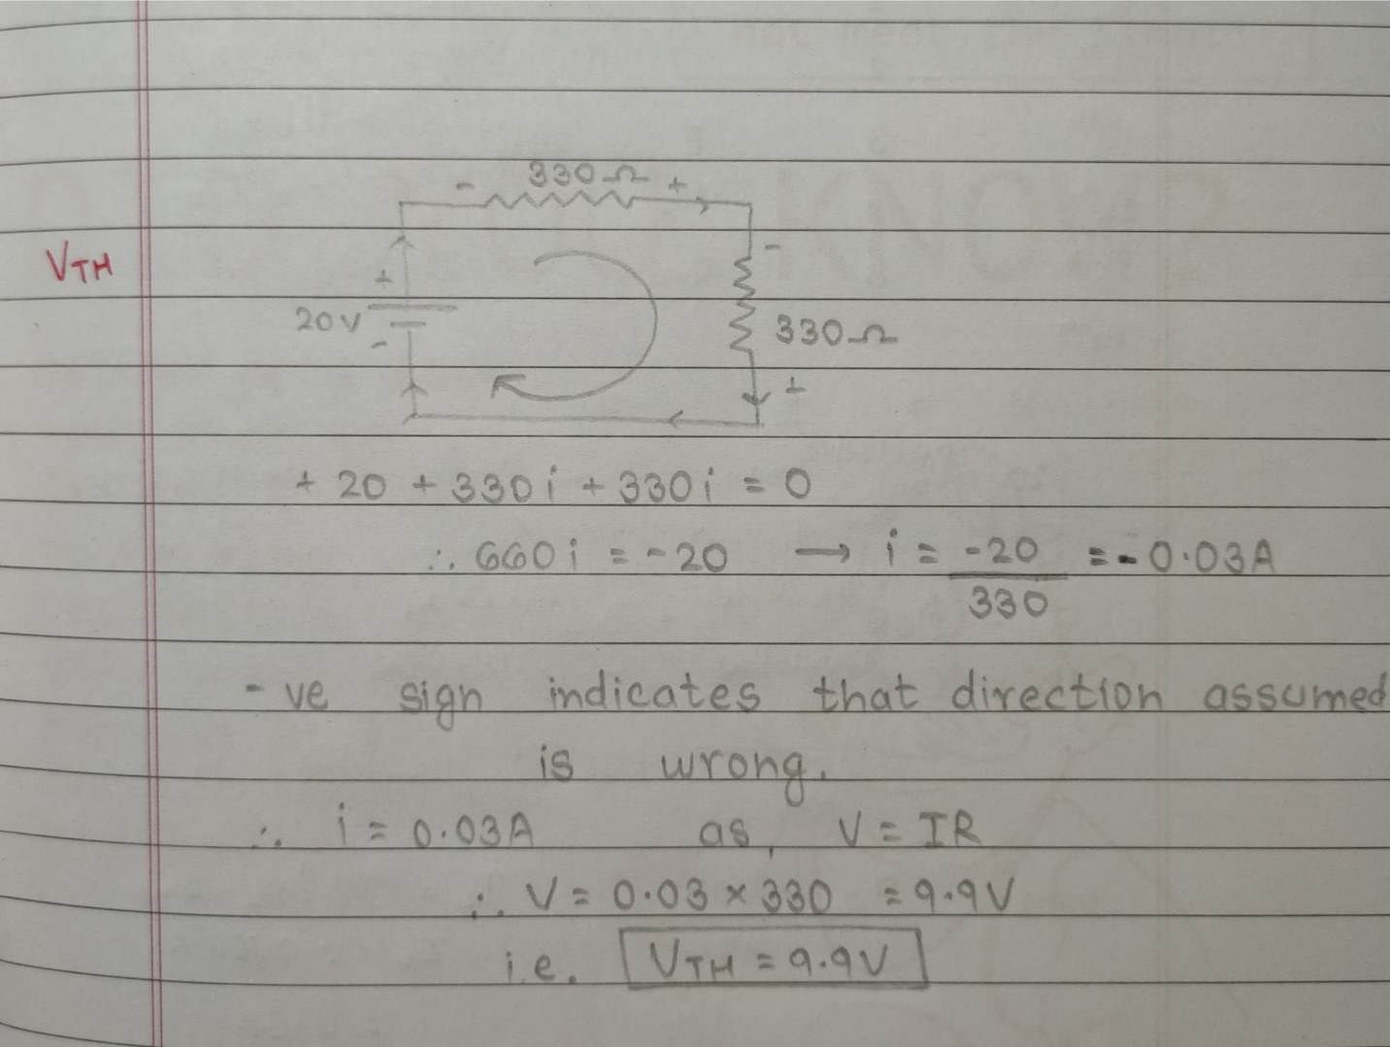

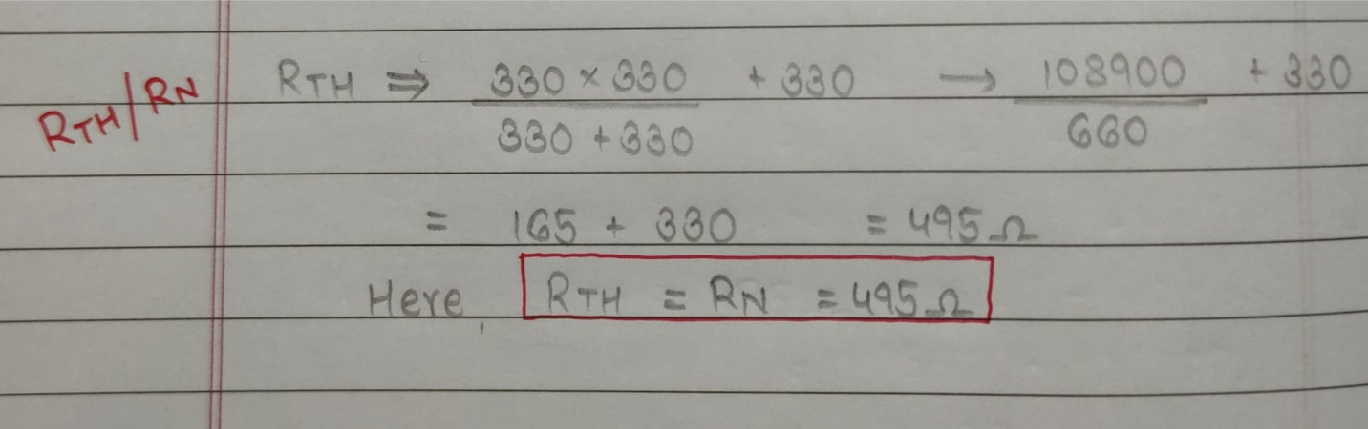

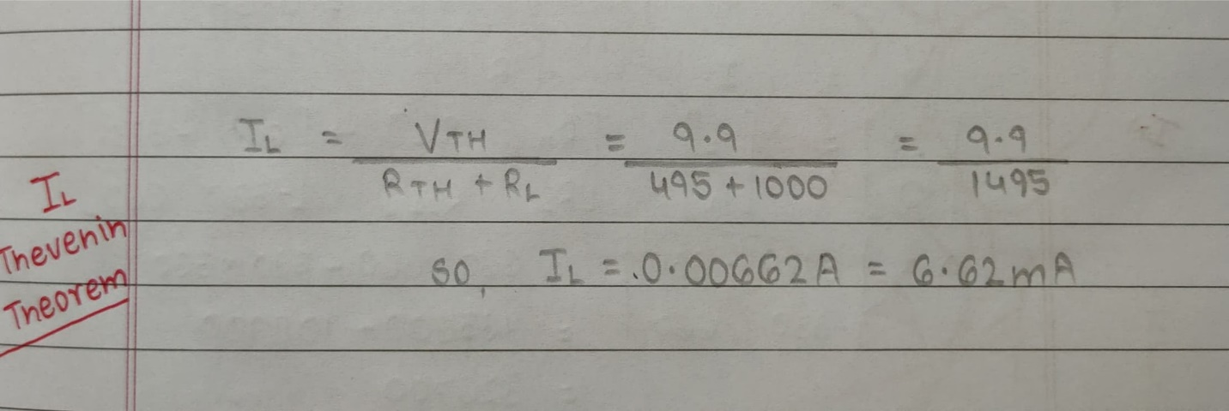

**Result:** *Thus, Thevenin’s theorem for the given circuit is verified & IL=6.69mA, VTH=10V, RTH=495ohm.*

***Screenshots of E-Circuits with input voltage of 20V.***

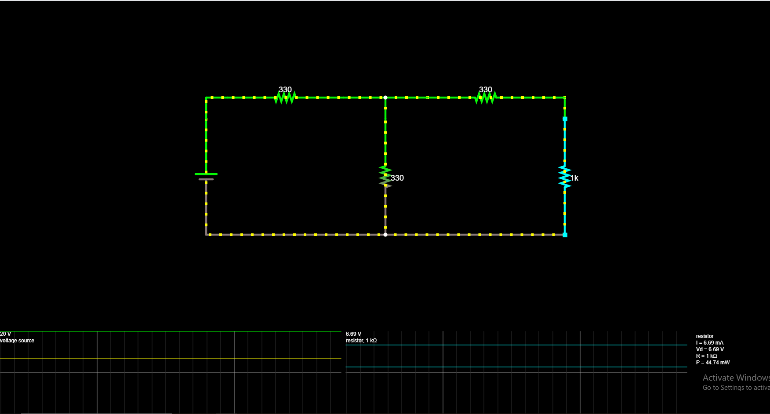

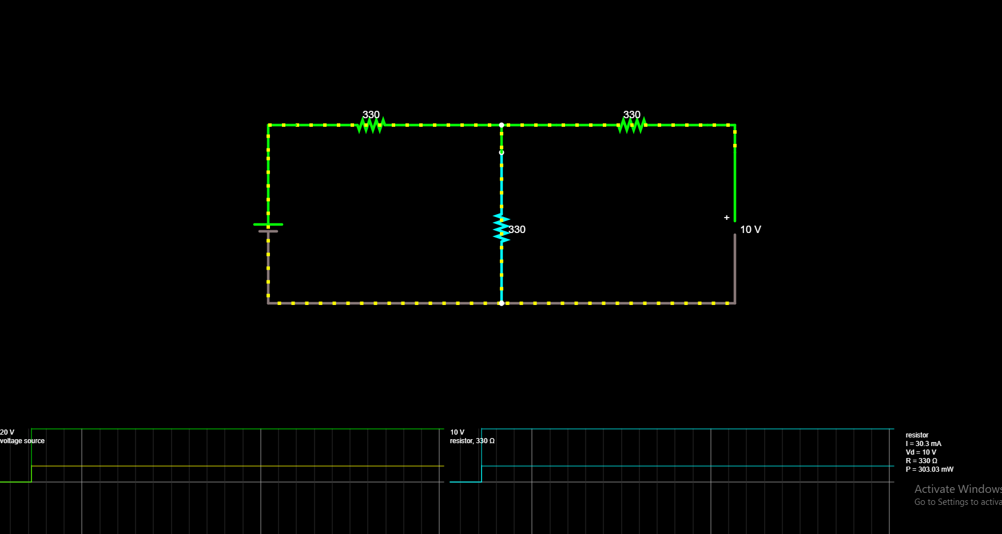

|  |  |
| --- | --- |
| **Experiment No. 2 b)**  **Date : 08/10/2020** | **VERIFICATION OF NORTON’S THEOREM** |

**Aim:**

To verify Norton’s theorem for the given circuit.

**Apparatus Required:**

|  |  |  |  |
| --- | --- | --- | --- |
| Sl.No. | Apparatus | Range | Quantity |
| 1 | Ammeter | (0-10mA) MC  (0-30mA) MC | 1  1 |
| 2 | Resistors | 330, 1KΩ | 3,1 |
| 3 | RPS | (0-30V) | 2 |
| 4 | Bread Board | -- | 1 |
| 5 | Wires | -- | Required |

**Statement:**

Any linear, bilateral, active two terminal network can be replaced by an equivalent current source (IN) in parallel with Norton’s resistance (RN)

**Precautions:**

1. Voltage control knob of RPS should be kept at minimum position.
2. Current control knob of RPS should be kept at maximum position.

**Procedure:**

1. Connections are given as per circuit diagram.
2. Set a particular value in RPS and note down the ammeter readings in the original circuit.

**To Find IN:**

1. Remove the load resistance and short circuit the terminals.
2. For the same RPS voltage note down the ammeter readings.

**To Find RN:**

1. Remove RPS and short circuit the terminal and remove the load and note down the resistance across the two terminals.

**Equivalent Circuit:**

1. Set IN and RN and note down the ammeter readings.
2. Verify Norton’s theorem.

**To find load current in circuit 1:**

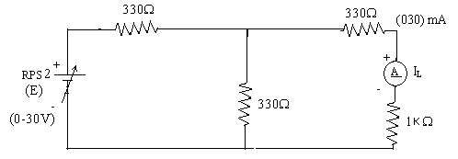

**To find IN**

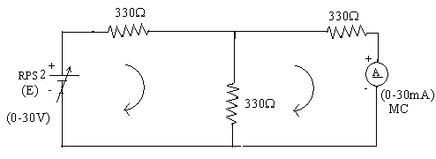

**To find RN**

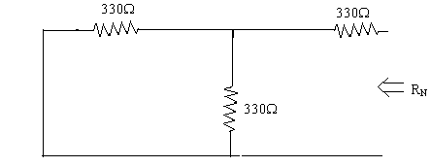

**Norton’s equivalent circuit**

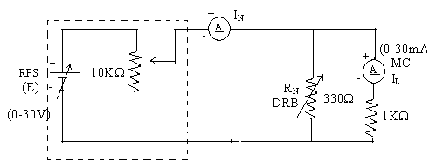

Constant current source

**Theoretical and Practical Values**

|  |  |  |  |  |  |
| --- | --- | --- | --- | --- | --- |
|  | E  (volts) | IN  (mA) | RN  (Ω) | IL (mA) | |
| Circuit - I | Equivalent Circuit |
| Theoretical Values | 20 | 20.0 | 495 | 6.68 | - |
| Practical Values | 20 | 20.2 | 495 | 6.69 | - |

**Model Calculations:**

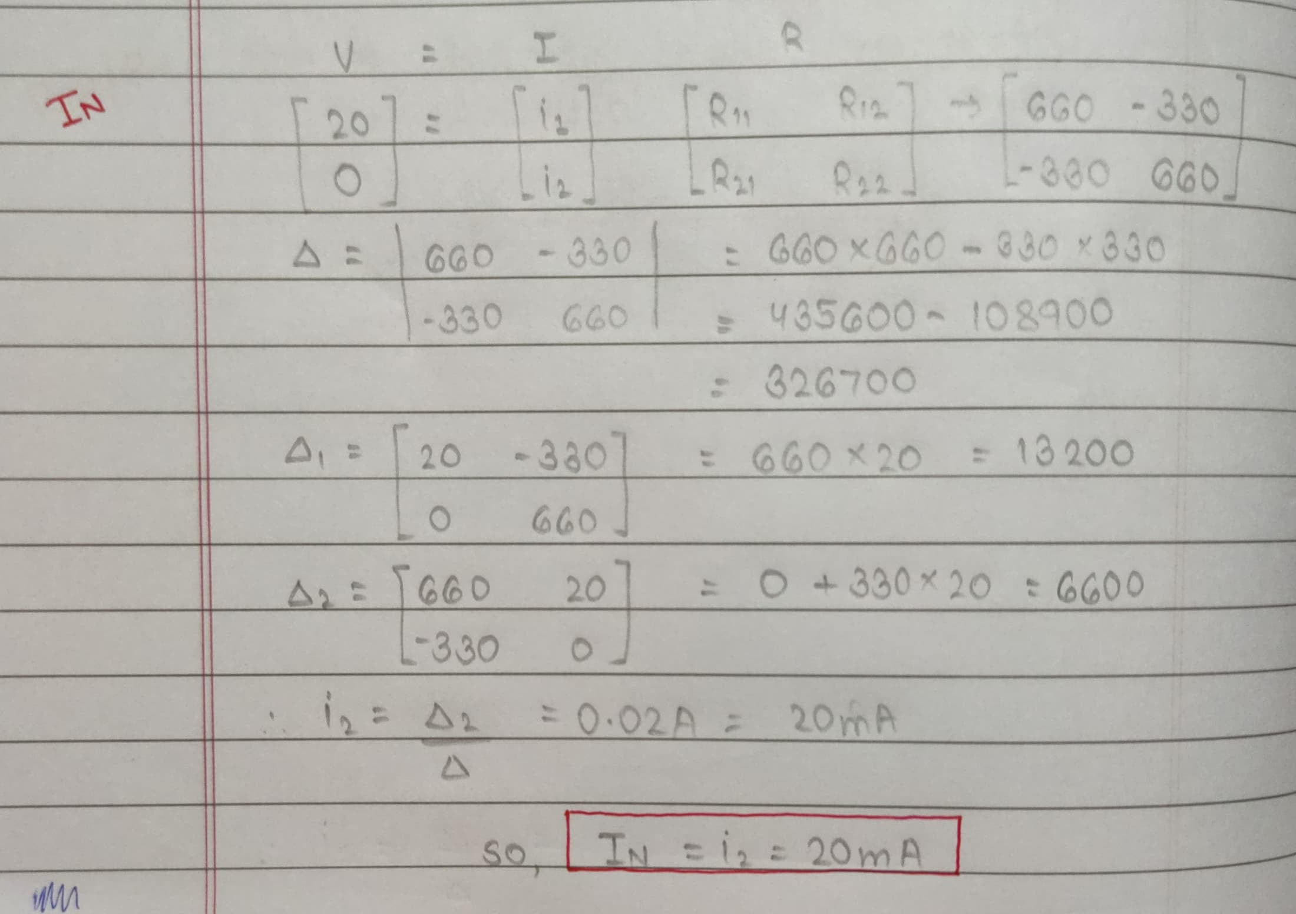



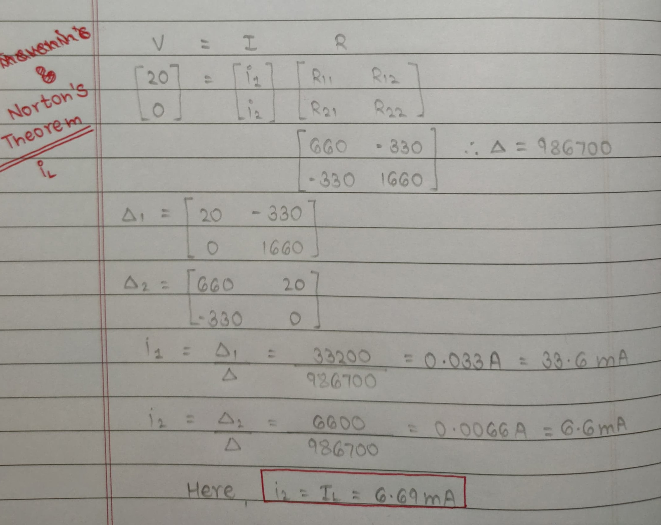

**Result:** *Thus, Norton’s theorem for the given circuit is verified & IL=6.69mA, IN=20.2mA, RN=495ohm.*

***Screenshots of E-Circuits with input voltage of 20V.***



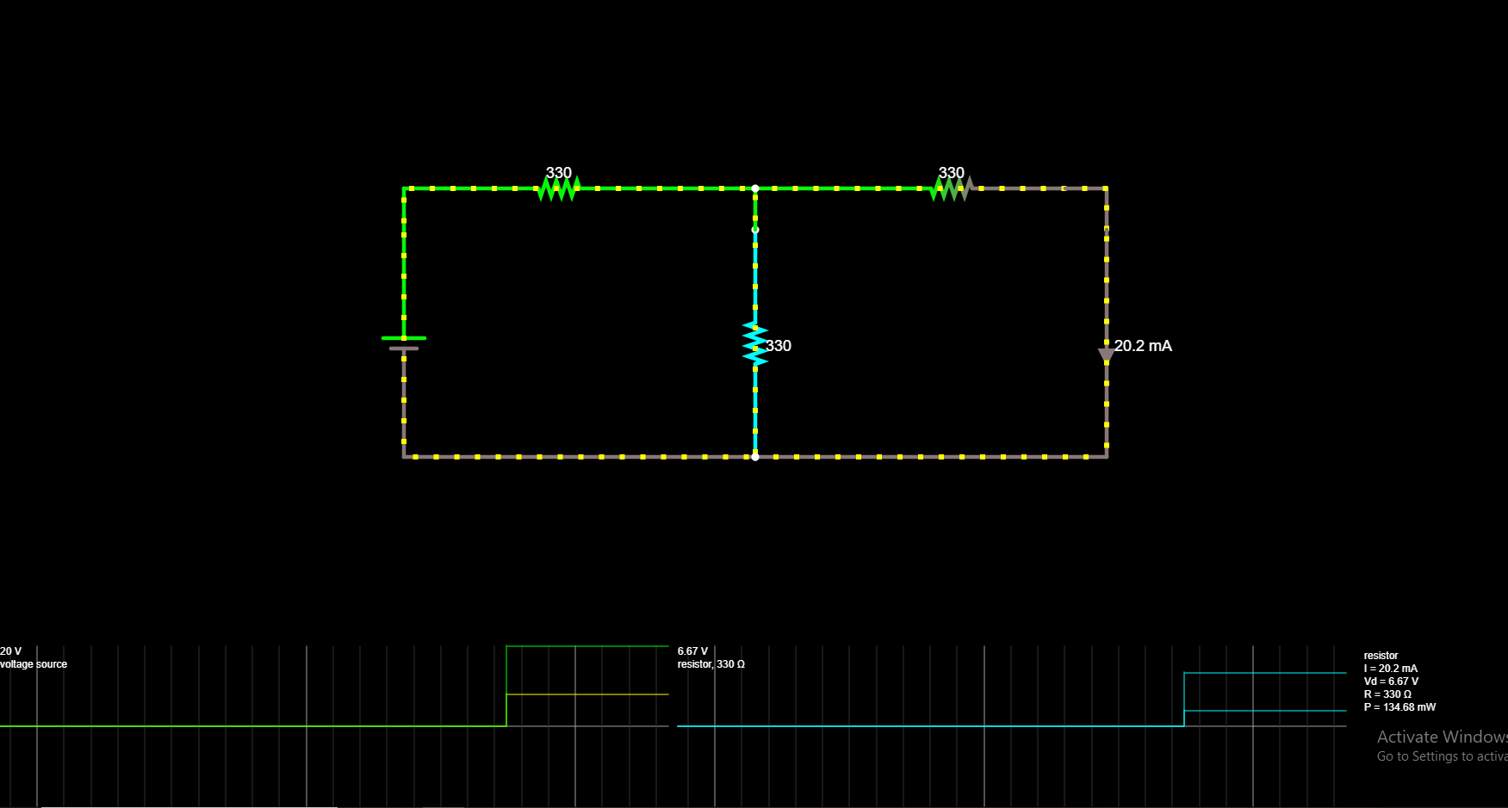

|  |  |
| --- | --- |
| **Experiment No. 2 c)**  **Date : 08/10/2020** | **VERIFICATION OF MAXIMUM POWER TRANSFER THEOREM** |

**Aim:**

To verify maximum power transfer theorem for the given circuit.

**Apparatus Required:**

|  |  |  |  |
| --- | --- | --- | --- |
| Sl.No. | Apparatus | Range | Quantity |
| 1 | RPS | (0-30V) | 1 |
| 2 | Voltmeter | (0-10V) MC | 1 |
| 3 | Resistor | 1KΩ, 1.3KΩ, 3Ω | 3 |
| 4 | DRB | -- | 1 |
| 5 | Bread Board & wires | -- | Required |

**Statement:**

In a linear, bilateral circuit the maximum power will be transferred from source to the load when load resistance is equal to source resistance.

**Precautions:**

1. Voltage control knob of RPS should be kept at minimum position.
2. Current control knob of RPS should be kept at maximum position.

**Procedure:**

**Circuit – I**

1. Connections are given as per the diagram and set a particular voltage in RPS.
2. Vary RL and note down the corresponding ammeter and voltmeter reading.
3. Repeat the procedure for different values of RL & Tabulate it.
4. Calculate the power for each value of RL.

**To find VTH:**

1. Remove the load, and determine the open circuit voltage using multimeter (VTH)

**To find RTH:**

1. Remove the load and short circuit the voltage source (RPS).
2. Find the looking back resistance (RTH) using multimeter.

**Equivalent Circuit:**

1. Set VTH using RPS and RTH using DRB and note down the ammeter reading.
2. Calculate the power delivered to the load (RL = RTH)
3. Verify maximum transfer theorem.

**Circuit - 1**

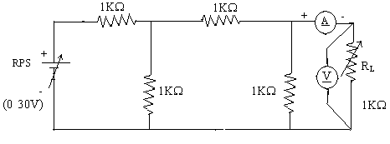

**To find VTH**

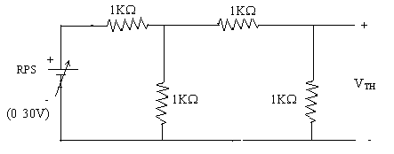

**To find RTH**

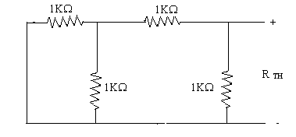

**Thevenin’s Equation Circuit**

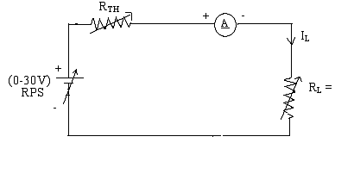

**Power VS RL**

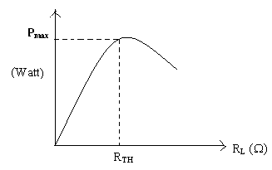

**Circuit – I**

|  |  |  |  |  |
| --- | --- | --- | --- | --- |
| **Sr. No.** | **RL (Ω)** | **I (mA)** | **V(V)** | **P=VI (watts)** |
| *1.*  *2.*  *3.*  *4.*  *5.*  *6.*  *7.*  *8.*  *9.*  *10.* | *100*  *200*  *300*  *400*  *500*  *600*  *700*  *800*  *900*  *1000* | *5.68*  *4.98*  *4.43*  *4.00*  *3.64*  *3.34*  *3.06*  *2.84*  *2.66*  *2.51* | *0.59*  *1.01*  *1.34*  *1.60*  *1.82*  *2.00*  *2.16*  *2.29*  *2.41*  *2.50* | *3.3512*  *5.0298*  *5.9362*  *6.4000*  *6.6248*  *6.6800*  *6.6096*  *6.5036*  *6.4106*  *6.2750* |

**To find Thevenin’s equivalent circuit**

|  |  |  |  |  |
| --- | --- | --- | --- | --- |
|  | **VTH (V)** | **RTH (Ω)** | **IL (mA)** | **P (milli watts)** |
| **Theoretical Values** | 4 | 600 | 2.50 | 10 |
| **Practical Values** | 4 | 600 | 2.50 | 10 |

**Model Calculations:**

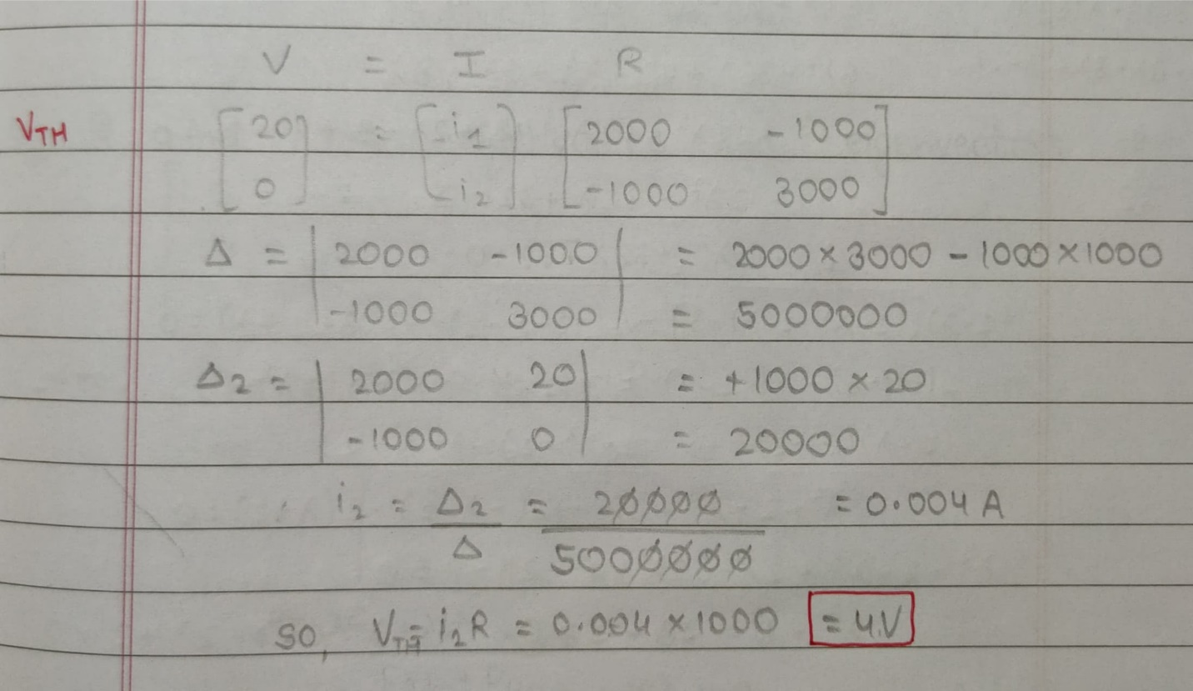

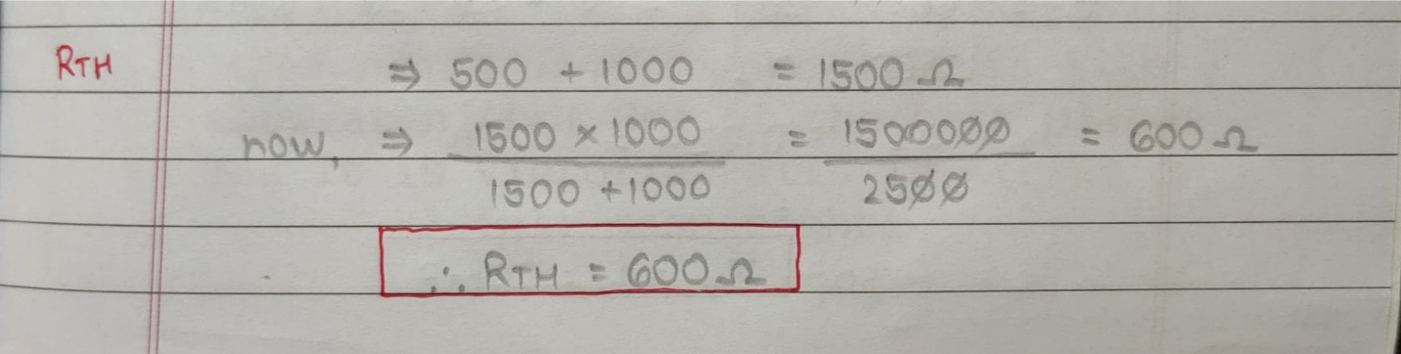

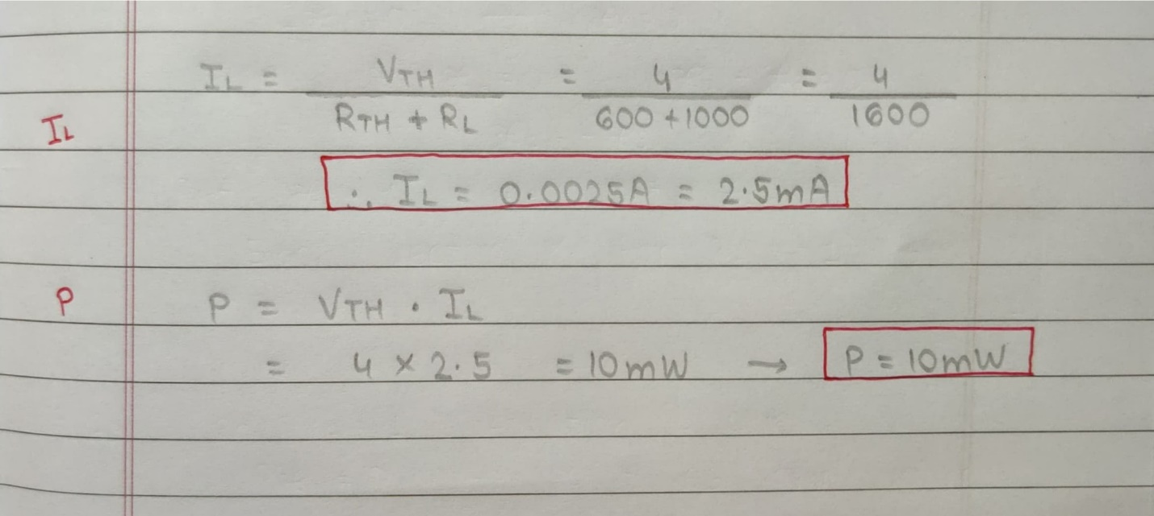

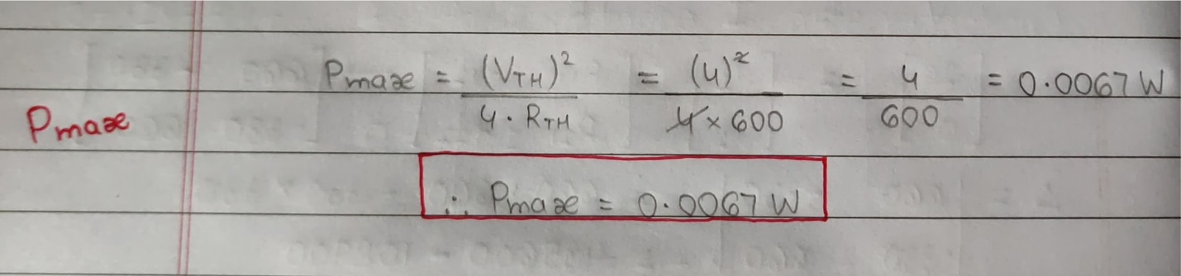

**Graph:**

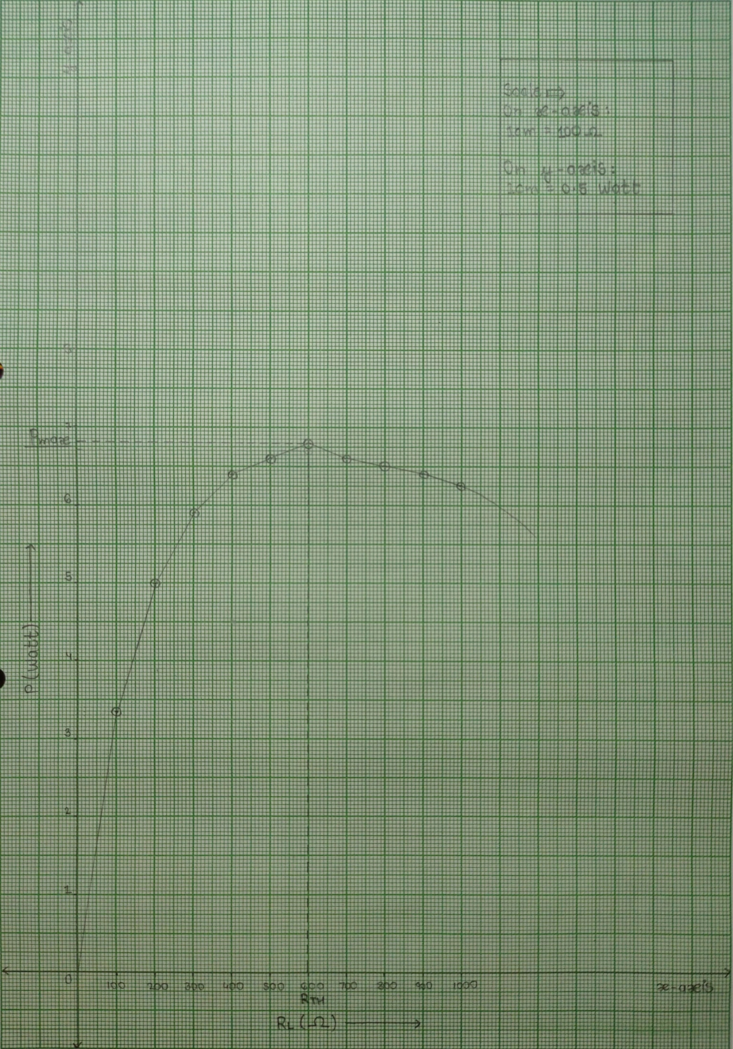

**Result:***Thus, Maximum Power Transfer theorem for the given circuit is verified & IL=1.45mA, VTH=4V, RTH=1666.6ohm.*

***Screenshots of E-Circuits with input voltage of 20V.***

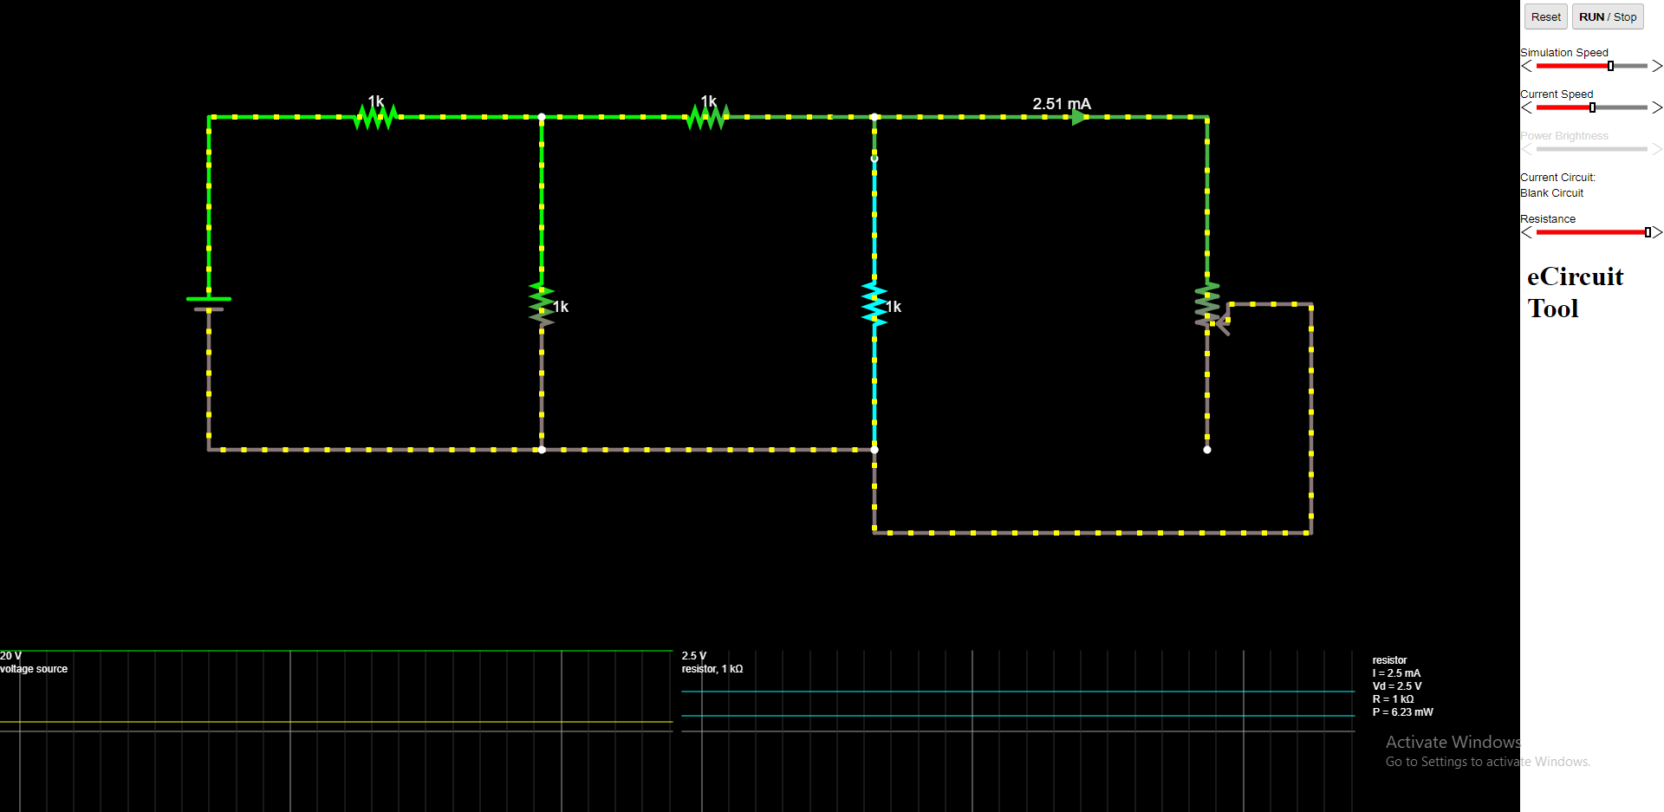

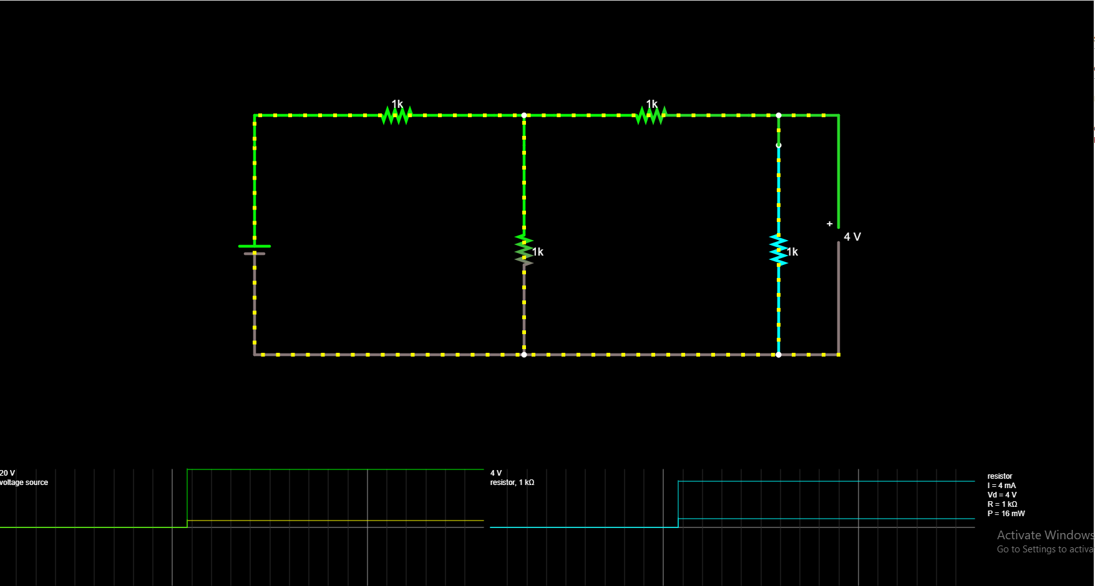

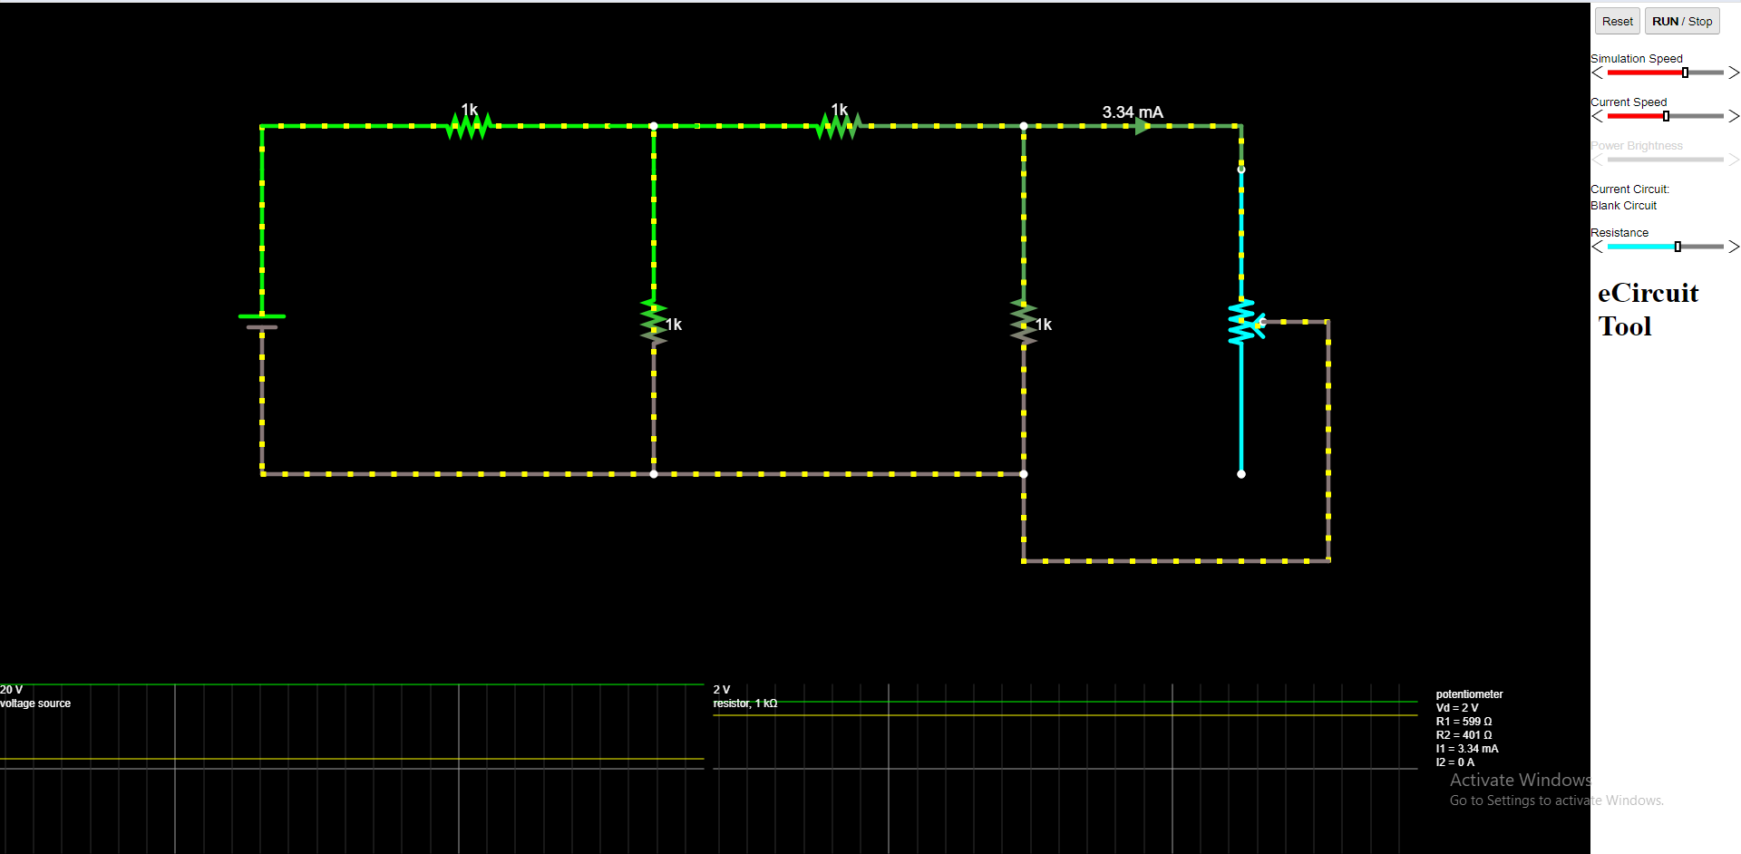

**POST LAB QUESTIONS**

**1. State Thevenin’s Theorem.**

**Ans :- *Thevenin’s Theorem****states that “*Any linear circuit containing several voltages and resistances can be replaced by just one single voltage in series with a single resistance connected across the load*“.*

**2. Draw the Thevenin’s equivalent circuit.**

**Ans :-**

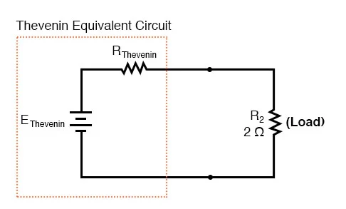

**3. State maximum power transfer theorem.**

**Ans :-*****The maximum power transfer theorem*** *states that “*The maximum amount of power will be dissipated in the load resistance if it is equal in value to the Thevenin or Norton source resistance of the network supplying the power*“.*

**4. Write some applications of maximum transfer theorem.**

**Ans :-** *1)* *Maximum power transfer theorem is applied on the public address system where the circuit is make in order to create maximum power transfer with the help of making speaker and amplifier equal to each other.*

*2) It is also applicable on car engine where power needed for the motor starter will depend on the motor resistance as well as the battery resistance, on equaling of these resistance power transferred toward engine will be maximum.*

*3)*  *It is also help in making a circuit having maximum power dissipation correctly at the load of resistance.*

**5. Write the steps to find IN .**

**Ans :- *Step 1:*** *Short the load resistor.*

***Step 2:*** *Calculate/measure the Short Circuit Current. This is the Norton Current (IN).*

**6. What are the steps to solve Maximum power transfer Theorem?**

**Ans :- *Step 1:****Remove the load resistance of the circuit.*

***Step 2:****Find the Thevenin’s resistance (RTH) of the source network looking through the open-circuited load terminals.*

***Step 3:****As per the maximum power transfer theorem, RTH is the load resistance of the network, i.e., RL = RTH that allows maximum power transfer.*

***Step 4:****Maximum Power Transfer is calculated by the below equation:*

***(Pmax) = V2TH / 4RTH***